**Pampered Pets**

**DEVELOPMENT: EXECUTIVE SUMMARY**

Group 3 Security and Risk Management 24 October 2022

# **INTRODUCTION**

The purpose of this report is to provide an executive summary and guidance to Pampered Pets management in relation to the potential risks, specifically quality and supply chain risks, which the organisation should anticipate as it transitions into a digitisation journey and expanding the business online and world-wide. Provide practical recommendations and the appropriate actions in managing and mitigating the identified risks based on their probabilities of occurring and impact to Pampered Pets.

This summary will also provide a blueprint of a business continuity/disaster recovery (BC/DR) strategy based on the business requirements, recommend a suitable solution, and provide guidance pertaining to vendor lock-in dynamics.

# **QUALITY AND SUPPLY CHAIN RISKS**

Several Quality and Supply Chain Risks for Pampered Pets digitalisation journey were identified and listed in the table 2.1. below:

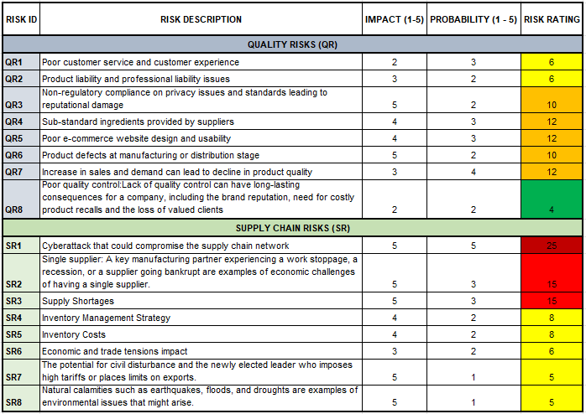

*Table 2.1. Risk Register*

### **Risk Modelling Approach**

#### A 5x5 Risk matrix is used as a modelling approach to provide a simplified and comprehensive view to Pampered Pets management on the various risks, their impact, and probabilities, and to provide insight on which risks are to be prioritised from the planning and analysis stage of the project.

#### Evaluating risks during the risk analysis stage is best done by using tools such as a 5×5 risk matrix. This can then result in a quantified expression of risk, having the output of the risk assessment as a numeric value or a qualitative description on the level of risk. (Guevara, 2022)

#### Table 2.2 below illustrates the risk matrices and represents the combination of the probability (X-axis) of the risk occurring and the impact (Y-axis) of the risk. Each component is assigned a value between 1 and 5 and color-coding is also used for ease of reference.

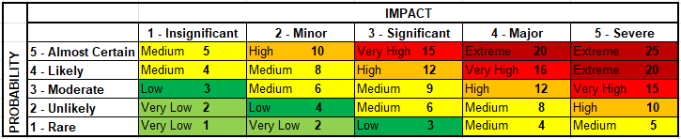

*Table 2.2 Risk Matrix (Probability X-axis, Impact Y-axis)*

Table 2.3. below depicts the probability/ likelihood risk rating levels and the Impact / Severity risk rating level.

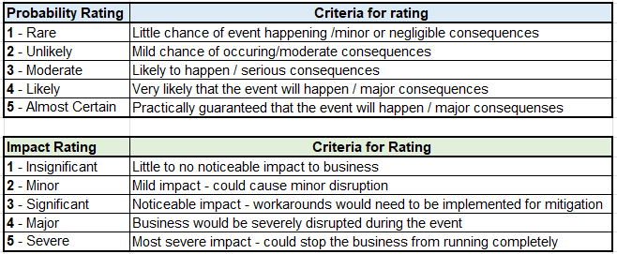

*Table 2.3. Probability and Impact risk rating levels*

The risk rating is calculated by multiplying the probability rating and the impact rating. A numerical value between 1 and 5; 1 being the lowest and 5 being the highest; is given to the impact and the probability to determine representation of the risk and action to be taken, this is illustrated in table 2.4 below.



*Table 2.4 Risk Calculation*

#### Assumptions

#### Initial teething problems with move of business model from local to international/online model.

#### Quality of goods from new suppliers may not be of a high enough standard.

#### We can assume that as the new business model is online, the company will face typical cyber security issues (Raghavan et al, 2017).

#### We can assume that the staff will need a period of adjusting to the new online operation model.

* New Skillset and Staff need to be acquired to complement the business model and align with different cultural backgrounds.

## SUMMARY OF RESULTS AND RECOMMENDATIONS

**Summary of Results**

There are two risk categories in the assessment which are quality risks and supply chain risks. Each risk measures and evaluates from different aspects. This gives an estimate of the likelihood that adjustments to the company's operations and supply chain could jeopardise the products' availability and quality.

As a result, there are a total of 8 identified risks for the quality risks highlighted in section 2. In that 8 quality risks, there are 5 high risks (62.5 %), 2 medium risks (25 %), and 1 low risk (12.5 %) representing the calculation of the risk rating as depicted in figure 3.1 below.

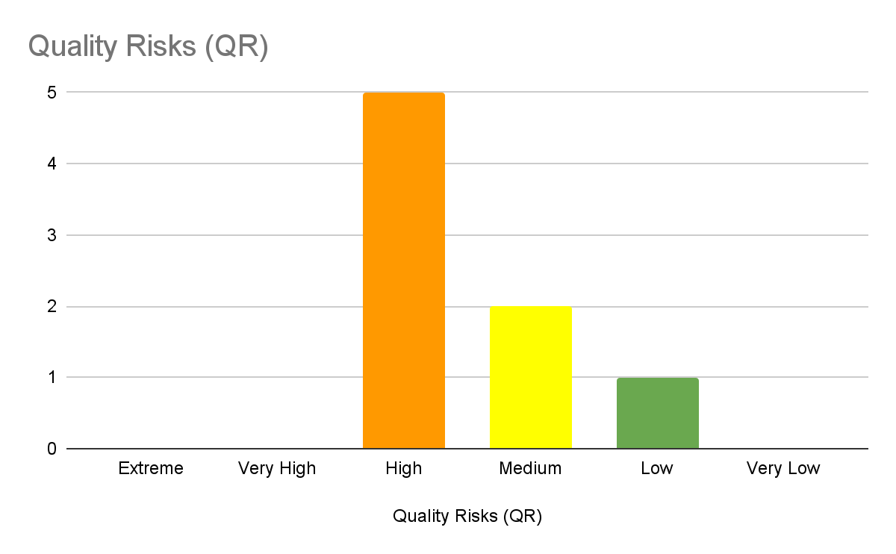

*Figure 3.1 Number of Quality Risk*

In addition, there are a total 8 identified risks pertaining to the supply chain as highlighted in section 2. In that 8 supply chain risks, there is 1 extreme risk (12.5 %), 2 very high risks (25 %), and 5 medium risks (62.5 %) representing the calculation of risk rating as depicted in figure 3.2 below.

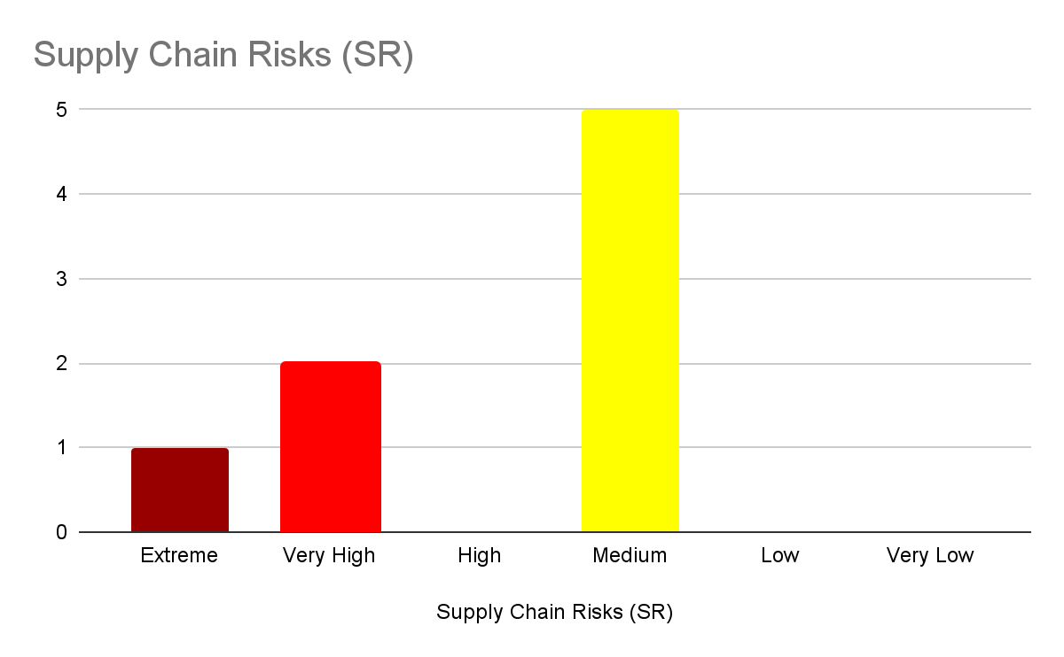

*Figure 3.2 Number of Supply Chain Risk*

In summary, there are a total 16 risks identified for quality risks and supply chain risks. It includes 1 extreme risk (6.25 %), 2 very high risks (12.5 %), 5 high risks (31.25 %), 7 medium risks (43.75 %), and 1 low risk (6.25 %) represented by the risk rating as illustrated in figure 3.3 below.

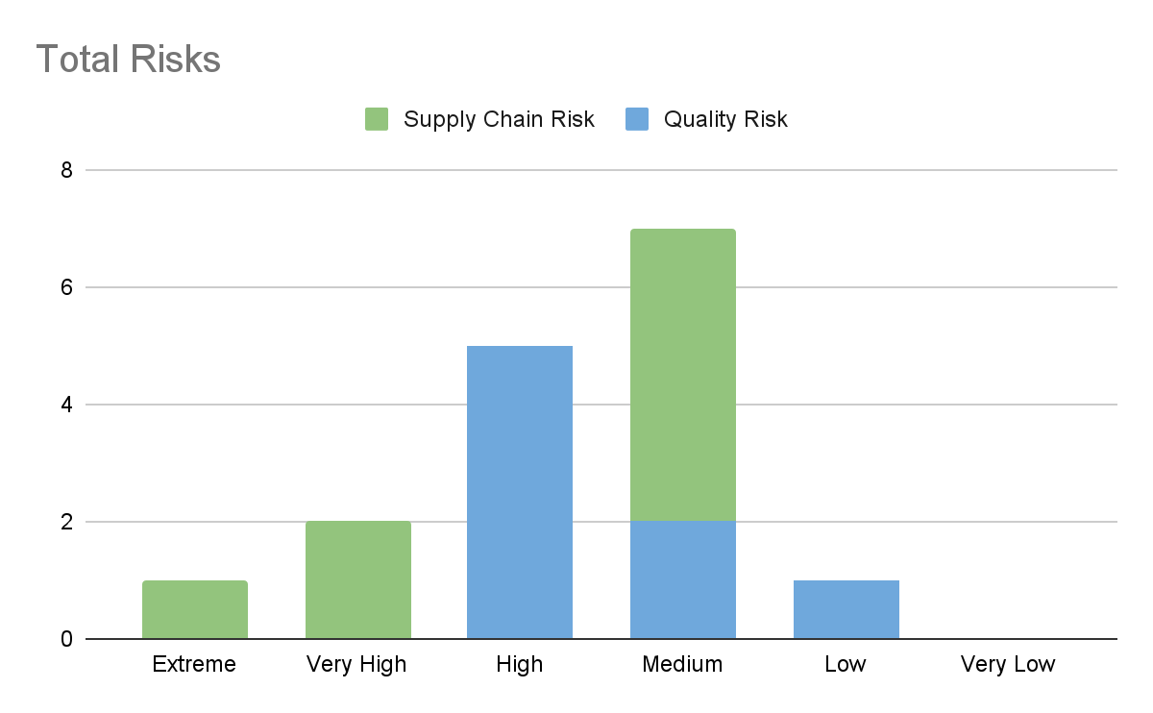

*Figure 3.3 Number of Total Risk*

**Recommendations**

Digital resources of all sorts and varieties are becoming more widely available and reasonably priced as the world becomes more data driven. By utilizing the technology, the company may streamline its operational procedures.

A few recommendations in priority for digitization are as follows:

Priority 1. Establish goals right away and build a solid strategy.

Building the plan around the objective aim to attain after giving it some thought. Those goals must first be defined then have a clear strategy on how they will be attained. To adequately measure success, the management team must also consider the kind of measurements and data that must be collected and examined. Have a clear dashboard of Key Performance Indicators (KPIs).

Priority 2. Utilize technological resources

You must realize that technology is not the sole factor if you plan to invest in it. Without a staff that understands how to make the most of digitalization, it will not be successful. Utilize technology as a tool to continually train the team and boost productivity. It could take the shape of lectures, workshops, or training sessions.

Priority 3. Make the Information Useful

Make sure to incorporate the data for the whole firm when it has been digitally compiled. A new digital system's implementation aims to improve and speed up workflows. And all the data stored, and the systems must be compliant with the current standards and regulations such as GDPR, PCI-DSS, and other regulatory requirements relevant in each jurisdiction. Failure to do this can consequently lead to a blind spot if teams and department heads are not aware of what the business is doing and can subsequently lead to the inability to react timeously when an incident occurs.

Priority 4. Choose the Proper Technology

Select the appropriate technology for the business if the desired goal is to have a reputable digital presence and raise digital awareness throughout the whole organization. Utilizing a supply chain management solution helps management create a more transparent, productive, traceable, and scalable company on a cloud-based platform.

1. **BUSINESS CONTINUITY/ DISASTER RECOVERY (DR) SOLUTION**

With the decision to migrate the Pampered Pets business to a digitised model, it is necessary that the online shop is available 24/7/365. In addition to the shop being moved online, there will be several automated Warehouses as well as new alliances with International Supply Chain partners. Communication between these entities is vital.

The current business model is not reliant on complex IT services, and therefore, the current staff are not qualified or experienced enough to provide the required level of services. To that end, partnering with a Cloud Service Provider (CSP) (TechTarget, ND) is recommended. Compared to the existing setup, this is a major increase in business costs.

The Cloud deployment should be implemented in a Software as a Service (SaaS) model, where the CSP is responsible for all hardware, software, security, applications, and website hosting.

We would suggest that Pampered Pets stays with one of the market leading CSPs (Gartner, 2021), as they cater for small/medium businesses, and all have a flexible payment policy.

Recommended CSP platforms – Amazon (AWS), Google (GCP) or Microsoft Azure.

This reliance on online connectivity, makes it essential that a business continuity (BC) / Disaster Recovery (DR) strategy is developed and implemented.

Whilst designing a strategy for a BC/DR plan, there are 2 factors that are typically considered – Recovery Time Objective (RTO) and Recovery Point Objective (RPO) (Acronis, 2020).

RPO is the amount of data that can afford to be lost during an incident, before causing significant harm to the business. This is measured in time. In Contrast, RTO is the amount of time that an application or system can be unavailable, before causing significant harm to the business – also measured in time.

The requirements from the business are extremely strict, both RTO and RPO are less than a minute, so we must implement a high-availability Active/Active solution.

All 3 recommended CSPs can also provide DRAAS (Disaster Recovery as a Service). To ensure business continuity during an incident, the CSPs should be asked to implement a multi-site redundant deployment in separate Cloud Data Centres (DC), A Zone-to-Zone DR that replicates across short distances and will have low latency and yield a low RPO.

Based on the failover requirements, this level of service requires that any applications/databases hosted, are continuously replicating data between the DCs to remain in sync. During an incident, automatic failover between the locations will occur almost immediately with minimal loss of data.

There is a risk that with the DCs being so close together, that a single geographical event could affect the availability. It is possible to implement geographically separate DCs in the Cloud, but replication, latency, and failover timings would be affected.

Figure 4.1 below illustrates a high-level diagram of the architecture.

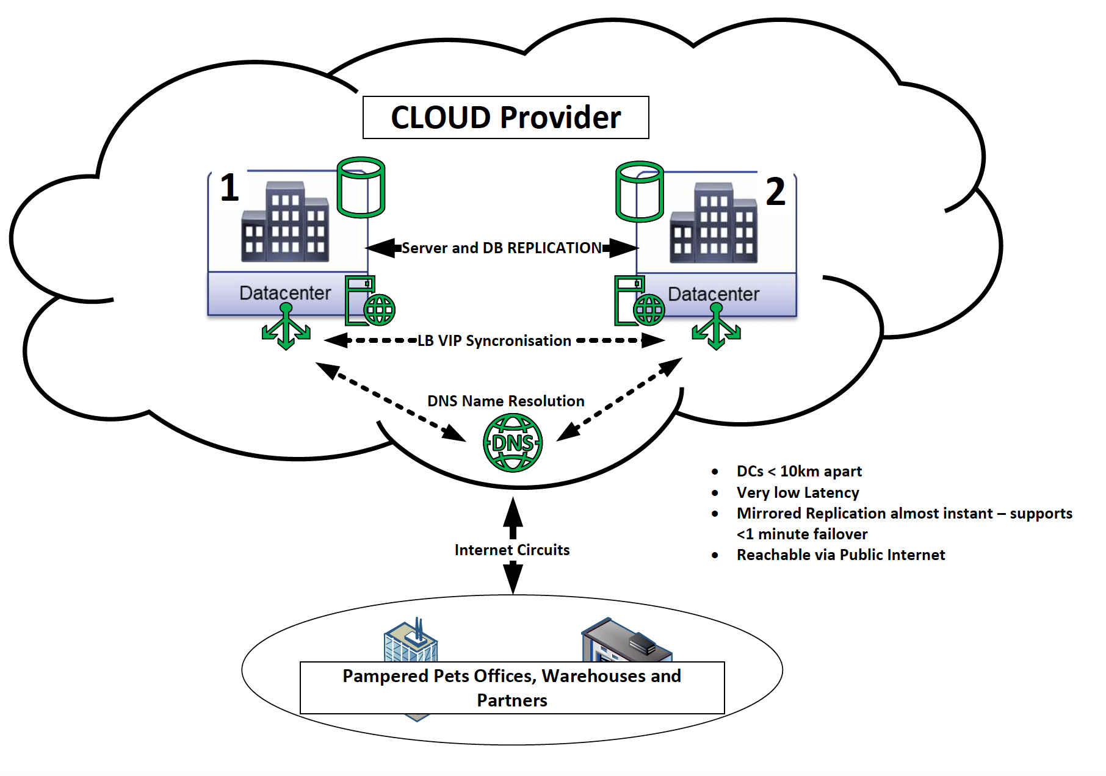

*Figure 4.1 High level CLOUD Deployment Design.*

As with all Cloud deployments, there is a risk of vendor lock-in (Cloudflare, ND), (Shinwari et al, 2018). If the data is stored in a particular CSP in a vendor-specific format, or a bespoke vendor application, it can be difficult to move away in the future without considerable rework and cost. To avoid this situation, it is recommended to use only open-standard and commonly available applications, APIs, Protocols, and data formats that would allow for the customer to change CSP more easily in the future.

A multi-cloud solution at this stage with different CSPs, would add unnecessary complexity. Regardless which CSP is chosen, they must ensure that they follow the relevant data protection rules and standards of all the countries where Pampered Pets are operating.

Finally, with the proposed IT operation being Cloud based, it is recommended that redundant internet circuits be implemented for resilience.

1. **CONCLUSION**

Pampered Pets is a successful Bricks n Mortar company with a reputation of providing high quality products to its customers. As such, the world of business is changing due to rapid technological advances that are reshaping how we conduct business. For Pampered Pets to sustain and grow the business. It is imperative that the business adapts to the technological advancements and utilise them at their disposal as it presents a plethora of opportunities.

In contrast, the opportunities presented also introduce new risks that can potentially be detrimental to the business. It is imperative that the quality and supply chain risks presented are taken into consideration, prioritised according to their ratings, and actioned accordingly.

In addition to the risks, Pampered pets will have to invest in a DRaaS solution that will provide an Active/Active architecture with failovers for smooth operation of the business 24/7/365 in case of a disaster and to enable them to continue with business operations. This solution is more costly but aligned to the business requirements.

Pampered Pets can have a great online presence and will transition in a smooth digital entity with a well-thought-out plan, roadmap and strategy in place to acquire the right skill sets, resources, and technologies to make informed and sound business decisions to achieve a successful online and international presence.

# **REFERENCES**

Guevara, P. (2022) *A Guide to Understanding 5x5 Risk Matrix.* Secure Culture. Available from: https://safetyculture.com/topics/risk-assessment/5x5-risk-matrix [Accessed 15 October 2022].

Raghavan, K., Desai, M., Rajkumar, P. (2017) *Managing Cybersecurity and e-Commerce Risks in Small Businesses*. Available from: http://ibii-us.org/Journals/JMSBI/V2N1/Publish/V2N1_2.pdf [Accessed 18 October 2022].

TechTarget, (ND). *Cloud Service Provider*. Available from: https://www.techtarget.com/searchitchannel/definition/cloud-service-provider-cloud-provider [Accessed 12 October 2022].

Gartner, (2021) *Magic Quadrant for Cloud Infrastructure and Platform Services*. Available from: https://www.gartner.com/doc/reprints?id=1-271OE4VR&ct=210802&st=sb [Accessed 12 October 2022].

Shinwari, N., Nasrullah, S., Sharma, N. (2018) *Vendor Lock-In Situation in Cloud Computing.* Available from: https://www.researchgate.net/profile/Neeta-Sharma-7/publication/329586396_VENDOR_LOCK-IN_SITUATION_IN_CLOUD_COMPUTING/links/5c10e329a6fdcc494fede43c/VENDOR-LOCK-IN-SITUATION-IN-CLOUD-COMPUTING.pdf [Accessed 12 October 2022].

Acronis, (2020) *RPO and RTO – definition and understanding the difference*. Available from: https://www.acronis.com/en-us/blog/posts/rto-rpo/ [Accessed 12 October 2022].

Cloudflare, (ND) *What is vendor lock-in? Vendor lock-in and cloud computing*. Available from: https://www.cloudflare.com/en-gb/learning/cloud/what-is-vendor-lock-in/ [Accessed 12 October 2022].